

Power bi visualizations research report

INFO601 Data Modelling and SQL



Student: STEPHEN li

**KPIs Questions**

**KPIs Question 1**

What were the total sales amount, total expenses, and total number of orders for each store in different cities during the two year of 2016 and 2017?

Below visuals can answer Question 1:

Multi-row card

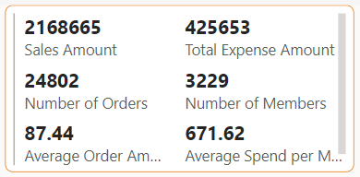

Map

Slicer

**KPIs Question 2**

What were the total sales amount and total sales quantity for all stores every month in 2016 and 2017?

Below visual can answer Question 2:

Line and stacked column chart

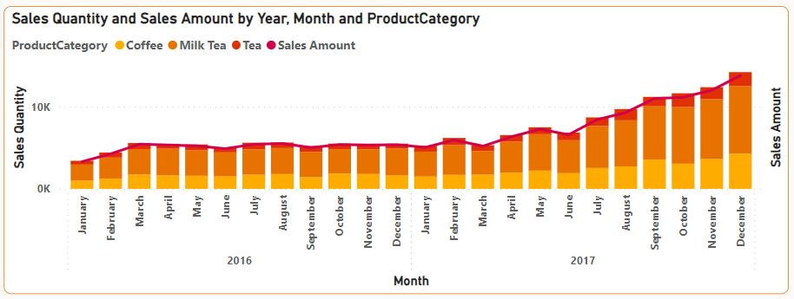

**KPIs Question 3**

Males or Females have a higher preference for purchasing drink products? What is the proportion of sales quantities corresponding to males and females?

Below visual can answer Question 3:

Pie chart

**KPIs Question 4**

What were total sales amount for each product and each product category?

Below visuals can answer Question 4:

Both are Clustered bar chart

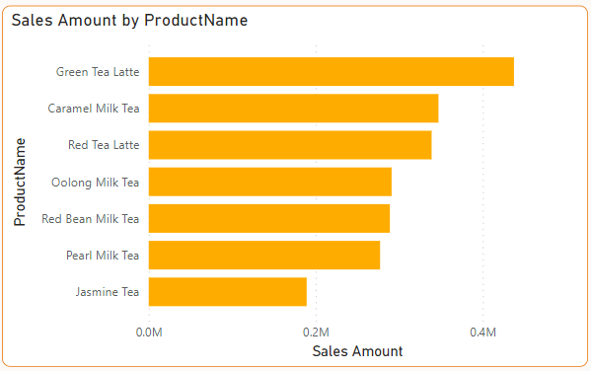

**Main Dashboard Page - Drink Store Sales**

Different type of visuals I select and reasons selected are below:

Multi-row card



Reasons selected:

Multi-row card can display key metrics which include Sales Amount, Total Expense Amount, Number of Orders, Number of Members, Average Order Amount, and Average Spend per Member in one card. It is user-friendly to get all metrics about Gong cha drink store(s) in one card.

Map

Reasons selected:

The map visual helps vividly display the variations in sales amount across different cities, with larger bubble size corresponding to higher sales amount. Additionally, the map visual can show the total area of each city, which is beneficial for the analysis of the relationship between city size and sales amount.

Slicer – Location

Reasons selected:

In this Slicer visual, I have included all the cities where the stores are located. This allows me to easily view the sales data for each city. I can click and select the city name, and the other visuals on the dashboard will update accordingly based on the chosen city.

Line and stacked column chart



Reasons selected:

This visual allows me to view the monthly variations in total sales amount and total sales quantity for all Gong cha drink store products in 2016 and 2017. It also enables me to observe the overall trend from 2016 to 2017. Moreover, this chart addresses my KPIs Question 2.

Slicer – Date filter

Reasons selected:

I can use the Date filter to specify any time period within the range of 2016 to 2017. This allows me to view the sales data for Gong cha drink store(s) within the selected time period. The Power BI date filter provides the flexibility to analyze sales performance, trends, and patterns over specific time intervals, enabling deeper insights into the business's performance and aiding in decision-making processes.

Pie chart

Reasons selected:

The pie chart clearly illustrates the purchasing preference between males and females. It also shows the proportion of sales quantity for each gender. Moreover, my KPIs question 3 can be effectively answered through this pie chart.

Clustered bar chart – Sales Amount by Product Name

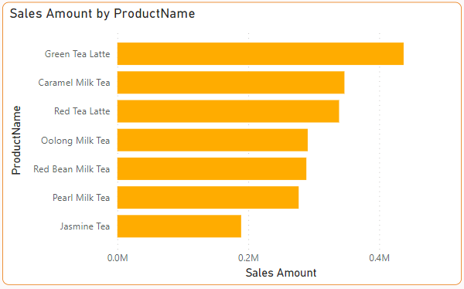

Reasons selected:

The clustered bar chart displays the sales amount on the x-axis and each different product on the y-axis. It provides a clear visual representation of the variations in sales amount between different products, allowing us to identify which product generates the highest revenue and which product has lower sales performance.

Clustered bar chart – Sales Amount by Product Category

Reasons selected:

Above clustered bar chart represents the sales amount on the x-axis and different product categories on the y-axis. It provides a clear visualization of the variations in sales amount among different product categories, including tea category, milk tea category, and coffee category. This chart also highlights a specific issue in the business: a significant loss in the tea category.

**The First Issue Page - Sales Amount Issue with Tea Category**

Different type of visuals I select and reasons selected are below:

Stacked bar chart

Reasons selected:

The stacked bar chart helps us visualize the sales amount for each product category. It shows what each product category (tea category, milk tea category, and coffee category) contains. Moreover, this chart reveals the main reason behind the low sales amount of the tea category, which is the presence of only one kind of product within the category, which is Jasmine Tea.

Stacked column chart

Reasons selected:

The x-axis represents all Gong cha store products, while the y-axis represents the sales quantity of each product. This chart allows us to clearly see the sales quantity for each product and determine if there are significant differences among them. It helps us analyze whether the low sales amount for tea category is related to the sales quantity of products.

Matrix

Reasons selected:

The Matrix visual presents data in a clear and organized format, allowing us to easily examine the sales amount for each product category in every city. It helps us determine if the sales amount for tea category products is consistently low across all cities. The Matrix visual is chosen because it provides a comprehensive view of sales amounts, facilitating comparison and analysis of tea category sales across different cities.

**The Second Issue Page - Sales Amount Issue in All Medium-sized Cities**

Different type of visuals I select and reasons selected are below:

Multi-row card

Reasons selected:

The Multi-row card visual displays the number of members and number of orders for Gong cha drink store(s), allowing me to analyze the differences in sales amount between big cities and medium-sized cities. It provides valuable insights into the factors contributing to variations in sales quantity.

Stacked bar chart

Reasons selected:

The graphical interface of the Stacked bar chart displays sales amount on the x-axis and different cities on the y-axis. It provides a visual representation of the variations in sales amount across different cities, making it easy to identify cities with high and low sales. Choosing to use the Stacked bar chart helps me identify an evident issue within Gong cha company: relatively low sales amount in medium-sized cities.

Map

Reasons selected:

The map visual helps vividly display the variations in sales amount across different cities, with larger bubble size corresponding to higher sales amount. Additionally, the map visual can show the total area of each city, which is beneficial for the analysis of the relationship between city size and sales amount.

Table

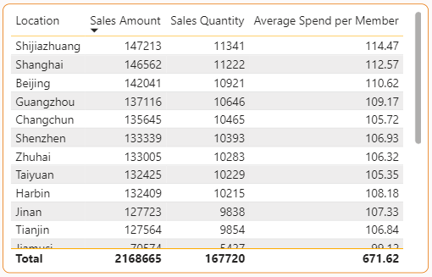

Reasons selected:

The visual shows the sales amount, sales quantity, and average spend per member for each city in tabular format. It is beneficial for analyzing the regional differences in the sales performance of Gong cha drink stores.

**Reference**

Microsoft. (2023). Power BI. Retrieved from <https://learn.microsoft.com/en-us/power-bi/>